
Object-Oriented-Programming Lab_CS-112L
UW-24-CS-BS-101
Registration NO:
Muhammad Talha_CS.2ndB
Lab Task # 01
UNIVERSITY OF WAH(UOW)

DEPARTMENT OF COMPUTER
SCIENCE

COURSE:

SUBMITTED TO:

Mr. Hassan Shafaqat
SUBMITTED BY:

Step # 01:
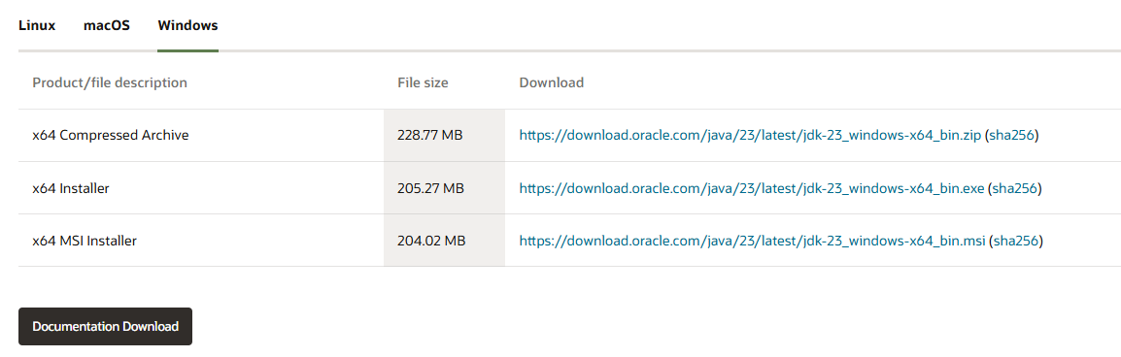
Download JDK

Step # 02:
Install and Run on cmd

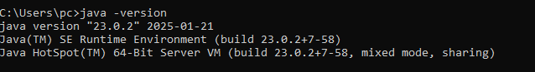
Step # 03:
Install Net Beans Throught this link

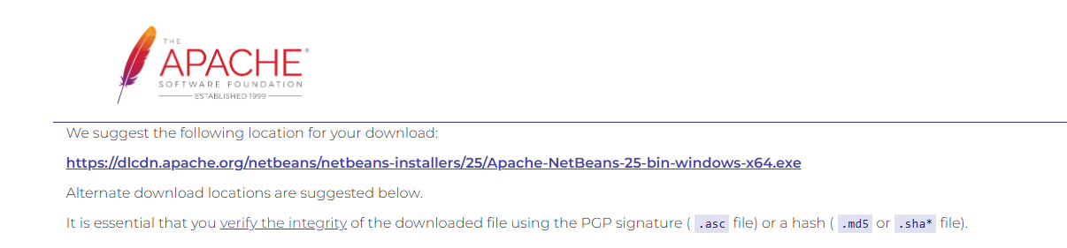

Step # 04:
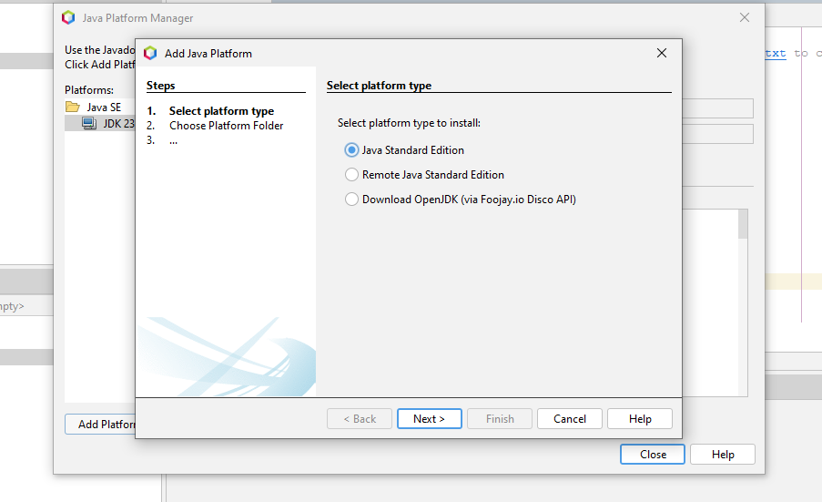
Adding Platform
Step # 05:
Making New Project file
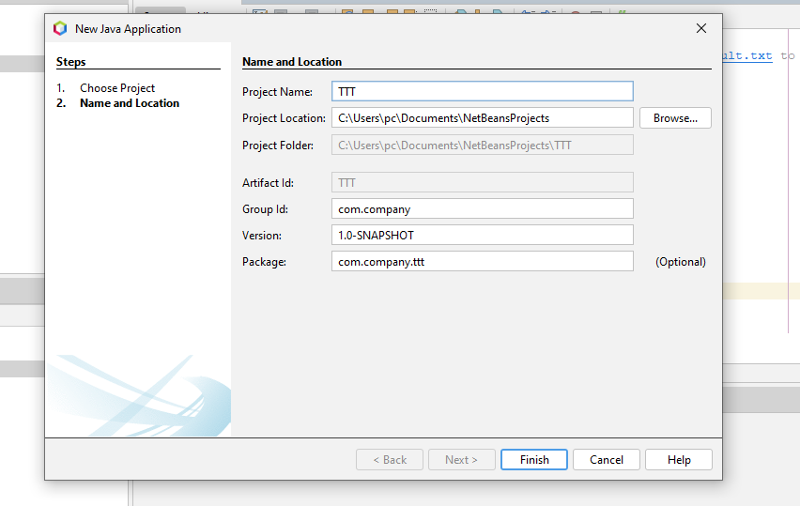

Step # 06:
Programs
Program # 01
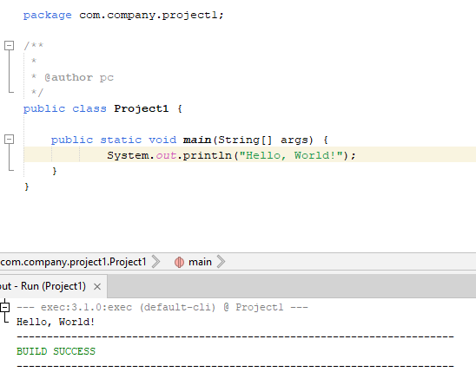
Program # 02
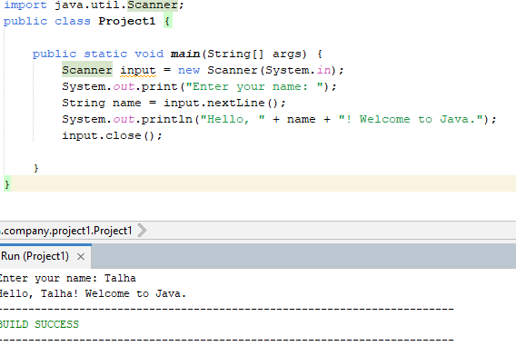

Program # 03

